Small Ruminants 101:
The Top 10 Avoidable Mistakes
(and How to Fix Them)

Sheep and Goat Info Night

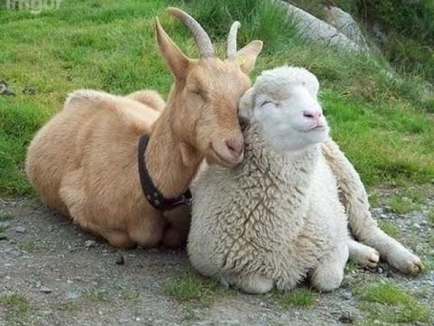

Tuesday, January 15, 2019
Mills and Petrie Building
704 N First Street
Ashton, Illinois
7:00 pm

Desserts and Snacks provided

Drawing for a free farm call!
(and other door prizes)

Please RSVP to
ashtonvet@ashtonvet.com
or
815-453-2171
By January 8, 2019

